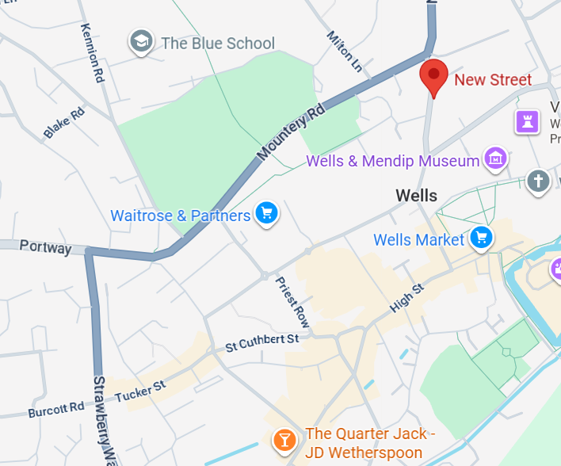
New Street Temporary Station for 376 through buses only

AREAS CLOSED
Portway - Temporary Station for 126, 173, 174. and terminating services 171, 374, 375 376a & 376.
Above services will also commence from here

