Locking Road Temporary Bus Stops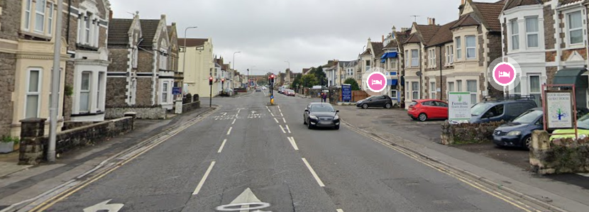
Temporary bus stop to Weston.
Temporary bus stop from Weston.

